**Geo Tracking of Waste and Triggering Alerts and Mapping Areas with High Waste Index**

**1. INTRODUCTION:**

In India, sixty-two million tons of municipal solid waste is generated in cities and towns every year. Out of these, approximately forty-three million tons of waste is collected properly. Proper waste management is becoming a serious problem in developing countries resulting in deterioration of the environment and poor public health. Several factors contribute to this improper management of waste collection and processing in India like dependence on the services of small labors or waste pickers for the collection of waste and extraction of any potential value from the waste. Mixed biodegradable and inert waste are often dumped together with e-waste without any segregation. These workers do not utilize any efficient method for processing and disposal of the waste and often practice open burning of the garbage. Also, municipal corporations have budgets that are insufficient to cover the costs associated with developing the proper waste collection, storage, treatment and disposal. Local bodies spend around Rs. 500–1000 per tone on solid waste management (SWM) with 70% of this amount spent on collection and 20% spent on transport. In this work, an IOT based waste management system has been proposed for monitoring the waste levels in garbage bins across the city by recording these levels without any human intervention. The status of the dustbins is monitored via user friendly user friendly applications. The locations and amount of waste present in these dustbins are used to determine the shortest possible route to be followed by the garbage collecting van which would help to reduce the cost of transportation and reduction of fuel consumption. The rest of the paper is organized as follows.

**1.1 Objective of the project:**

This paper aims to improve the efficiency of the garbage collection process by developing a system for monitoring waste levels in garbage bins using Machine learning for sending the measurements like the amount of waste level to the user. Two smart dustbins were designed for home use and public use which are monitored in real-time using the mobile applications. Notification alerts are also sent when the amount of waste exceeds a certain threshold level. These dustbins are connected wirelessly using Machine Learning based transceiver in the form of a mesh network to facilitate the transfer of the amount of waste present in these dustbins to the nearest garbage collection truck and an optimized shortest route to be followed by the garbage collector truck is calculated. The proposed system is user friendly, compact and cost-effective requiring minimum human intervention

**2. LITERATURE SURVEY:**

**"Challenges and opportunities associated with waste management in India,"**

India faces major environmental challenges associated with waste generation and inadequate waste collection, transport, treatment and disposal. Current systems in India cannot cope with the volumes of waste generated by an increasing urban population, and this impacts on the environment and public health. The challenges and barriers are significant, but so are the opportunities. This paper reports on an international seminar on ‘Sustainable solid waste management for cities: opportunities in South Asian Association for Regional Cooperation (SAARC) countries’ organized by the Council of Scientific and Industrial Research-National Environmental Engineering Research Institute and the Royal Society. A priority is to move from reliance on waste dumps that offer no environmental protection, to waste management systems that retain useful resources within the economy. Waste segregation at source and use of specialized waste processing facilities to separate recyclable materials has a key role. Disposal of residual waste after extraction of material resources needs engineered landfill sites and/or investment in waste-to-energy facilities. The potential for energy generation from landfill via methane extraction or thermal treatment is a major opportunity, but a key barrier is the shortage of qualified engineers and environmental professionals with the experience to deliver improved waste management systems in India.

**"Design of Smart Waste Management System,"**

In this paper we have developed a low cost, low power waste management system which will be applicable in regions which are not economically sound. This system enables us to collect the trash as and when the can is full or when the trash inside is decomposed compared to daily collection. This has been designed using an Machine Learning

**"A Proposed IOT Based Smart Waste Bin Management System with An Optimized Route: A Case Study of Ghana,"**

Waste management in Ghana has in recent times been a subject of discourse that pervades most of its industrial cities. The provision of waste bins at vantage points by waste management institutions is not enough to solve the problem of the current management system. In this paper, a proposed method that uses multiple solutions to address the issues of spillage and inefficient collection scheme is presented. The system provides a monitoring platform for the waste management institution to handle the alert records by creating orders for the garbage collectors/drivers which can be accessed via a mobile application system. The proposed system includes a smart waste bin which has a Machine Learning constructed and affixed to the top of the bins to detect bin level status and communicate to drivers and management office via SMS and application system. A work order is created once a utilizes is full which can be received by the drivers and routing system regarding the state of bins distributed within a specific geographic area that can be assessed on the drivers' phone. The system implantation works successfully, making it possible to monitor waste bin status in real-time but occasionally had high latency which was primarily due to the use of Machine Learning

"**Solid Waste Monitoring and Management using Machine learning,"**

This paper deals with the solid waste monitoring and management system using Machine Learning associate with intelligent systems. The system consists of Machine learning for tracking vehicle position. The proposed system would be able to monitor the solid waste collection process and management the overall collection process. It would provide in time solid waste collection, tracking the vehicle position through the GIS database and also overcome the disadvantages such as usage of minimum route, low fuel cost, clean environment and available vehicle. The technologies that would be used in the proposed system are good enough to ensure the practical and perfect for solid waste collection process monitoring and management for green environment.

**"IOT based Smart Waste Management System using Machine Learning,"**

As we know that the population is increasing every day. The population must be neat and clean. And we should bring cleanliness in Our habits. As we can see that in many Cities the overflow garbage bins are Creating unhealthy and harmful Environment. This paper is a survey that is based on Smart Garbage management in cities using IoT. This survey helps to keep our environment clean by implementing various smart garbage management approach to discard of all these problems an IOT based real time garbage and waste bins detection system by integrating different sensing and communication technologies is proposed. The system in divided into three section, the first section consists of bins with sensor nodes installed in it that are moisture, ultrasonic and odour sensor interfaced with microcontroller. Second segment contain of Wi-Fi module for data move to the server and third section is web page.

**3. SYSTEM ANALYSIS**

**3.1 EXISTING SYSTEM**:

The Hazardous Waste Tracking System (HWTS) is the California Department of Toxic Substances Control’s (DTSC) data repository for hazardous waste manifest and ID Number information. DTSC relies on HWTS for issuing and tracking ID numbers, registering transporters, and providing information to analyze hazardous waste activities for policy purposes and enforcement. The system generates reports from 1993 to the present on hazardous waste shipments for generators, transporters, and treatment, storage and disposal facilities (TSDFs). These reports are available to the public and subject to the limitations contained in the [Disclaimer and Data Limitations Statement](https://hwts.dtsc.ca.gov/documents/Internal_CUPA_Disclaimer.pdf)

**Disadvantages:**

* + Low accuracy
  + Time taking process

**3.2 PROPOSED SYSTEM:**

By creating a system to monitor waste levels in trash cans using ultrasonic sensors and linking them to an Machine Learning . The measurements, such as the amount of waste level, will be sent to the user. For residential and public use, two smart trash cans were created, and they can both be tracked in real time using mobile applications. When the amount of garbage surpasses a specific threshold, notification alerts are also delivered. To enable the transfer of the amount of rubbish contained in these trash cans to the closest garbage collection vehicle and an optimum shortest route to be followed, these trash cans are connected wirelessly utilizing Machine Learning based transceivers in the form of a mesh network

**ADVANTAGES:**

* High accuracy
* Easy to detect

**Modules Information:**

.To implements this project we have designed following modules

This project consists of two modules

User Module: In this module user can upload waste images and add location details.

Here student asking to display location in map but the problem is to display location in map we need to have latitude and longitude values then only we can display exact location in map and we don’t have any sensor or devices to track latitude and longitude. So we can’t use maps.

Waste Collector Module: In this module waste collectors will upload video and this video will start playing and we need to consider this video as its playing from webcam or drone. Video player continuously scan images to find pattern match between current location and user uploaded waste images. If pattern in video matched with user uploaded waste images then application will inform to waste collector via bounding boxes.

Note: here we are matching images using pattern match technique which is not 100% reliable for matching. If two different images having little similar pattern or colour then this technique will detect the match. So sometime two different images can also raise output as match.

**3.3. PROCESS MODEL USED WITH JUSTIFICATION**

**SDLC (Umbrella Model):**

**Umbrella Activity**

**Umbrella Activity**

**Umbrella Activity**

1. Feasibility Study
2. TEAM FORMATION
3. Project Specification PREPARATION

Business Requirement Documentation

ANALYSIS & DESIGN

CODE

UNIT TEST

DOCUMENT CONTROL

ASSESSMENT

TRAINING

INTEGRATION & SYSTEM TESTING

DELIVERY/INSTALLATION

ACCEPTANCE TEST

Requirements Gathering

SDLC is nothing but Software Development Life Cycle. It is a standard which is used by software industry to develop good software.

**Stages in SDLC:**

* Requirement Gathering
* Analysis
* Designing
* Coding
* Testing
* Maintenance

**Requirements Gathering** **stage:**

The requirements gathering process takes as its input the goals identified in the high-level requirements section of the project plan. Each goal will be refined into a set of one or more requirements. These requirements define the major functions of the intended application, define operational data areas and reference data areas, and define the initial data entities. Major functions include critical processes to be managed, as well as mission critical inputs, outputs and reports. A user class hierarchy is developed and associated with these major functions, data areas, and data entities. Each of these definitions is termed a Requirement. Requirements are identified by unique requirement identifiers and, at minimum, contain a requirement title and textual description.

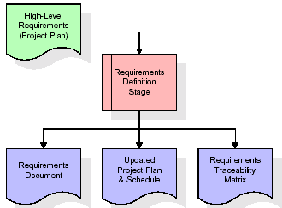

These requirements are fully described in the primary deliverables for this stage: the Requirements Document and the Requirements Traceability Matrix (RTM). The requirements document contains complete descriptions of each requirement, including diagrams and references to external documents as necessary. Note that detailed listings of database tables and fields are *not* included in the requirements document.

The title of each requirement is also placed into the first version of the RTM, along with the title of each goal from the project plan. The purpose of the RTM is to show that the product components developed during each stage of the software development lifecycle are formally connected to the components developed in prior stages.

In the requirements stage, the RTM consists of a list of high-level requirements, or goals, by title, with a listing of associated requirements for each goal, listed by requirement title. In this hierarchical listing, the RTM shows that each requirement developed during this stage is formally linked to a specific product goal. In this format, each requirement can be traced to a specific product goal, hence the term requirements traceability.

The outputs of the requirements definition stage include the requirements document, the RTM, and an updated project plan.

* Feasibility study is all about identification of problems in a project.
* No. of staff required to handle a project is represented as Team Formation, in this case only modules are individual tasks will be assigned to employees who are working for that project.
* Project Specifications are all about representing of various possible inputs submitting to the server and corresponding outputs along with reports maintained by administrator.

**Analysis Stage:**

The planning stage establishes a bird's eye view of the intended software product, and uses this to establish the basic project structure, evaluate feasibility and risks associated with the project, and describe appropriate management and technical approaches.

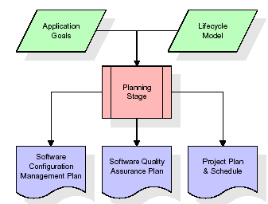

The most critical section of the project plan is a listing of high-level product requirements, also referred to as goals. All of the software product requirements to be developed during the requirements definition stage flow from one or more of these goals. The minimum information for each goal consists of a title and textual description, although additional information and references to external documents may be included. The outputs of the project planning stage are the configuration management plan, the quality assurance plan, and the project plan and schedule, with a detailed listing of scheduled activities for the upcoming Requirements stage, and high level estimates of effort for the out stages.

**Designing Stage:**

The design stage takes as its initial input the requirements identified in the approved requirements document. For each requirement, a set of one or more design elements will be produced as a result of interviews, workshops, and/or prototype efforts. Design elements describe the desired software features in detail, and generally include functional hierarchy diagrams, screen layout diagrams, tables of business rules, business process diagrams, pseudo code, and a complete entity-relationship diagram with a full data dictionary. These design elements are intended to describe the software in sufficient detail that skilled programmers may develop the software with minimal additional input.

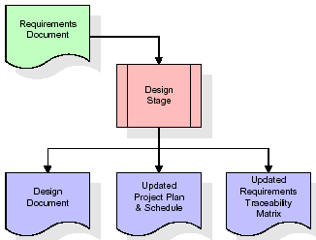  
When the design document is finalized and accepted, the RTM is updated to show that each design element is formally associated with a specific requirement. The outputs of the design stage are the design document, an updated RTM, and an updated project plan.

**Development (Coding) Stage:**

The development stage takes as its primary input the design elements described in the approved design document. For each design element, a set of one or more software artifacts will be produced. Software artifacts include but are not limited to menus, dialogs, and data management forms, data reporting formats, and specialized procedures and functions. Appropriate test cases will be developed for each set of functionally related software artifacts, and an online help system will be developed to guide users in their interactions with the software.

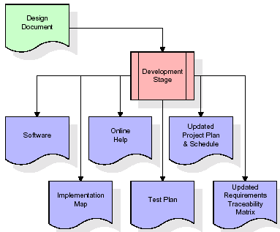

The RTM will be updated to show that each developed artifact is linked to a specific design element, and that each developed artifact has one or more corresponding test case items. At this point, the RTM is in its final configuration. The outputs of the development stage include a fully functional set of software that satisfies the requirements and design elements previously documented, an online help system that describes the operation of the software, an implementation map that identifies the primary code entry points for all major system functions, a test plan that describes the test cases to be used to validate the correctness and completeness of the software, an updated RTM, and an updated project plan.

**Integration & Test Stage:**

During the integration and test stage, the software artifacts, online help, and test data are migrated from the development environment to a separate test environment. At this point, all test cases are run to verify the correctness and completeness of the software. Successful execution of the test suite confirms a robust and complete migration capability. During this stage, reference data is finalized for production use and production users are identified and linked to their appropriate roles. The final reference data (or links to reference data source files) and production user list are compiled into the Production Initiation Plan.

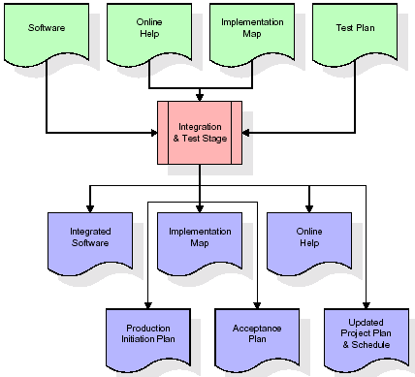

The outputs of the integration and test stage include an integrated set of software, an online help system, an implementation map, a production initiation plan that describes reference data and production users, an acceptance plan which contains the final suite of test cases, and an updated project plan.

* **Installation & Acceptance Test:**

During the installation and acceptance stage, the software artifacts, online help, and initial production data are loa ded onto the production server. At this point, all test cases are run to verify the correctness and completeness of the software. Successful execution of the test suite is a prerequisite to acceptance of the software by the customer.

After customer personnel have verified that the initial production data load is correct and the test suite has been executed with satisfactory results, the customer formally accepts the delivery of the software.

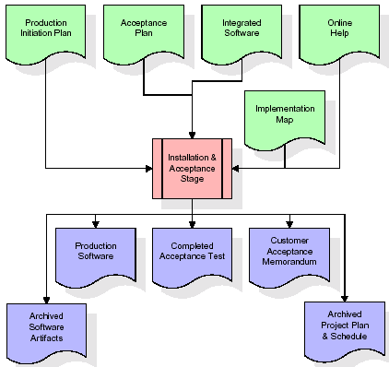

The primary outputs of the installation and acceptance stage include a production application, a completed acceptance test suite, and a memorandum of customer acceptance of the software. Finally, the PDR enters the last of the actual labor data into the project schedule and locks the project as a permanent project record. At this point the PDR "locks" the project by archiving all software items, the implementation map, the source code, and the documentation for future reference.

**Maintenance:**

Outer rectangle represents maintenance of a project, Maintenance team will start with requirement study, understanding of documentation later employees will be assigned work and they will undergo training on that particular assigned category. For this life cycle there is no end, it will be continued so on like an umbrella (no ending point to umbrella sticks).

**3.4. Software Requirement Specification**

**3.4.1. Overall Description**

A Software Requirements Specification (SRS) – a [requirements specification](http://en.wikipedia.org/wiki/Requirements_specification) for a [software system](http://en.wikipedia.org/wiki/Software_system) is a complete description of the behavior of a system to be developed. It includes a set of [use cases](http://en.wikipedia.org/wiki/Use_case) that describe all the interactions the users will have with the software. In addition to use cases, the SRS also contains non-functional requirements. [Nonfunctional requirements](http://en.wikipedia.org/wiki/Non-functional_requirements) are requirements which impose constraints on the design or implementation (such as [performance engineering](http://en.wikipedia.org/wiki/Performance_engineering) requirements, [quality](http://en.wikipedia.org/wiki/Quality_%28business%29) standards, or design constraints).

System requirements specification: A structured collection of information that embodies the requirements of a system. A [business analyst](http://en.wikipedia.org/wiki/Business_analyst), sometimes titled [system analyst](http://en.wikipedia.org/wiki/System_analyst), is responsible for analyzing the business needs of their clients and stakeholders to help identify business problems and propose solutions. Within the [systems development lifecycle](http://en.wikipedia.org/wiki/Systems_development_life_cycle) domain, the BA typically performs a liaison function between the business side of an enterprise and the information technology department or external service providers. Projects are subject to three sorts of requirements:

* [Business requirements](http://en.wikipedia.org/wiki/Business_requirements) describe in business terms what must be delivered or accomplished to provide value.
* Product requirements describe properties of a system or product (which could be one of several ways to accomplish a set of business requirements.)
* Process requirements describe activities performed by the developing organization. For instance, process requirements could specify .Preliminary investigation examine project feasibility, the likelihood the system will be useful to the organization. The main objective of the feasibility study is to test the Technical, Operational and Economical feasibility for adding new modules and debugging old running system. All system is feasible if they are unlimited resources and infinite time. There are aspects in the feasibility study portion of the preliminary investigation:
* **ECONOMIC FEASIBILITY**

A system can be developed technically and that will be used if installed must still be a good investment for the organization. In the economical feasibility, the development cost in creating the system is evaluated against the ultimate benefit derived from the new systems. Financial benefits must equal or exceed the costs. The system is economically feasible. It does not require any addition hardware or software. Since the interface for this system is developed using the existing resources and technologies available at NIC, There is nominal expenditure and economical feasibility for certain.

* **Operational Feasibility**

Proposed projects are beneficial only if they can be turned out into information system. That will meet the organization’s operating requirements. Operational feasibility aspects of the project are to be taken as an important part of the project implementation. This system is targeted to be in accordance with the above-mentioned issues. Beforehand, the management issues and user requirements have been taken into consideration. So there is no question of resistance from the users that can undermine the possible application benefits. The well-planned design would ensure the optimal utilization of the computer resources and would help in the improvement of performance status.

* **TECHNICAL FEASIBILITY**

Earlier no system existed to cater to the needs of ‘Secure Infrastructure Implementation System’. The current system developed is technically feasible. It is a web based user interface for audit workflow at NIC-CSD. Thus it provides an easy access to .the users. The database’s purpose is to create, establish and maintain a workflow among various entities in order to facilitate all concerned users in their various capacities or roles. Permission to the users would be granted based on the roles specified. Therefore, it provides the technical guarantee of accuracy, reliability and security.

**3.4.2. External Interface Requirements**

**User Interface**

The user interface of this system is a user friendly python Graphical User Interface.

**Hardware Interfaces**

The interaction between the user and the console is achieved through python capabilities.

**Software Interfaces**

The required software is python.

**SYSTEM REQUIREMENT:**

**HARDWARE REQUIREMENTS:**

# Processor - Intel i3(min)

* Speed - 1.1 Ghz
* RAM - 4GB(min)
* Hard Disk - 500 GB
* Key Board - Standard Windows Keyboard
* Mouse - Two or Three Button Mouse
* Monitor - SVGA

**SOFTWARE REQUIREMENTS:**

* Operating System - Windows10(min)
* Programming Language - Python 3.7.0

**4. SYSTEM DESIGN**

**CLASS DIAGRAM:**

The class diagram is the main building block of object oriented modeling. It is used both for general conceptual modeling of the systematic of the application, and for detailed modeling translating the models into programming code. Class diagrams can also be used for data modeling. The classes in a class diagram represent both the main objects, interactions in the application and the classes to be programmed. In the diagram, classes are represented with boxes which contain three parts:

* The upper part holds the name of the class
* The middle part contains the attributes of the class
* The bottom part gives the methods or operations the class can take or undertake



**USECASE DIAGRAM:**

A **use case diagram** at its simplest is a representation of a user's interaction with the system and depicting the specifications of a use case. A use case diagram can portray the different types of users of a system and the various ways that they interact with the system. This type of diagram is typically used in conjunction with the textual use case and will often be accompanied by other types of diagrams as well.



**SEQUENCE DIAGRAM:**

A **sequence diagram** is a kind of interaction diagram that shows how processes operate with one another and in what order. It is a construct of a Message Sequence Chart. A sequence diagram shows object interactions arranged in time sequence. It depicts the objects and classes involved in the scenario and the sequence of messages exchanged between the objects needed to carry out the functionality of the scenario. Sequence diagrams are typically associated with use case realizations in the Logical View of the system under development. Sequence diagrams are sometimes called **event diagrams**, **event scenarios**, and timing diagrams.



**COLLABORATION DIAGRAM:**

A collaboration diagram describes interactions among objects in terms of sequenced messages. Collaboration diagrams represent a combination of information taken from class, sequence, and use case diagrams describing both the static structure and dynamic behaviour of a system.



**COMPONENT DIAGRAM:**

In the Unified Modelling Language, a component diagram depicts how components are wired together to form larger components and or software systems. They are used to illustrate the structure of arbitrarily complex systems.

Components are wired together by using an assembly connector to connect the required interface of one component with the provided interface of another component. This illustrates the service consumer - service provider relationship between the two components.



**DEPLOYMENT DIAGRAM:**

A **deployment diagram** in the Unified Modeling Language models the *physical* deployment of artifacts on nodes. To describe a web site, for example, a deployment diagram would show what hardware components ("nodes") exist (e.g., a web server, an application server, and a database server), what software components ("artifacts") run on each node (e.g., web application, database), and how the different pieces are connected (e.g. JDBC, REST, RMI).

The nodes appear as boxes, and the artifacts allocated to each node appear as rectangles within the boxes. Nodes may have sub nodes, which appear as nested boxes. A single node in a deployment diagram may conceptually represent multiple physical nodes, such as a cluster of database servers.



**ACTIVITY DIAGRAM:**

Activity diagram is another important diagram in UML to describe dynamic aspects of the system. It is basically a flow chart to represent the flow form one activity to another activity. The activity can be described as an operation of the system. So the control flow is drawn from one operation to another. This flow can be sequential, branched or concurrent

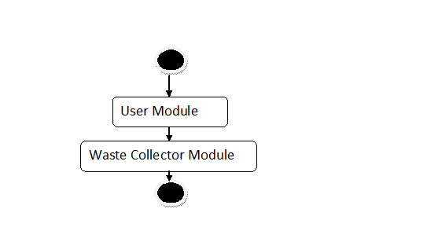

**Data flow :**

Data flow diagrams illustrate how data is processed by a system in terms of inputs and outputs. Data flow diagrams can be used to provide a clear representation of any business function. The technique starts with an overall picture of the business and continues by analyzing each of the functional areas of interest. This analysis can be carried out in precisely the level of detail required. The technique exploits a method called top-down expansion to conduct the analysis in a targeted way.

As the name suggests, Data Flow Diagram (DFD) is an illustration that explicates the passage of information in a process. A DFD can be easily drawn using simple symbols. Additionally, complicated processes can be easily automated by creating DFDs using easy-to-use, free downloadable diagramming tools. A DFD is a model for constructing and analyzing information processes. DFD illustrates the flow of information in a process depending upon the inputs and outputs. A DFD can also be referred to as a Process Model. A DFD demonstrates business or technical process with the support of the outside data saved, plus the data flowing from the process to another and the end results.

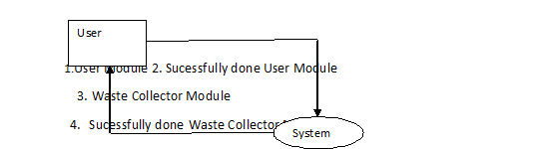

**5. IMPLEMETATION**

**5.1 Python**

Python is a general-purpose language. It has wide range of applications from Web development (like: Django and Bottle), scientific and mathematical computing (Orange, SymPy, NumPy) to desktop graphical user Interfaces (Pygame, Panda3D). The syntax of the language is clean and length of the code is relatively short. It's fun to work in Python because it allows you to think about the problem rather than focusing on the syntax.

**History of Python:**

Python is a fairly old language created by Guido Van Rossum. The design began in the late 1980s and was first released in February 1991.

**Why Python was created?**

In late 1980s, Guido Van Rossum was working on the Amoeba distributed operating system group. He wanted to use an interpreted language like ABC (ABC has simple easy-to-understand syntax) that could access the Amoeba system calls. So, he decided to create a language that was extensible. This led to design of a new language which was later named Python.

**Why the name Python?**

No. It wasn't named after a dangerous snake. Rossum was fan of a comedy series from late seventies. The name "Python" was adopted from the same series "Monty Python's Flying Circus".

**Features of Python:**

**A simple language which is easier to learn**

Python has a very simple and elegant syntax. It's much easier to read and write Python programs compared to other languages like: C++, Java, C#. Python makes programming fun and allows you to focus on the solution rather than syntax.

If you are a newbie, it's a great choice to start your journey with Python.

**Free and open-source**

You can freely use and distribute Python, even for commercial use. Not only can you use and distribute software’s written in it, you can even make changes to the Python's source code.

Python has a large community constantly improving it in each iteration.

**Portability**

You can move Python programs from one platform to another, and run it without any changes.

It runs seamlessly on almost all platforms including Windows, Mac OS X and Linux.

**Extensible and Embeddable**

Suppose an application requires high performance. You can easily combine pieces of C/C++ or other languages with Python code.

This will give your application high performance as well as scripting capabilities which other languages may not provide out of the box.

**A high-level, interpreted language**

Unlike C/C++, you don't have to worry about daunting tasks like memory management, garbage collection and so on.

Likewise, when you run Python code, it automatically converts your code to the language your computer understands. You don't need to worry about any lower-level operations.

**Large standard libraries to solve common tasks**

Python has a number of standard libraries which makes life of a programmer much easier since you don't have to write all the code yourself. For example: Need to connect MySQL database on a Web server? You can use MySQLdb library using import MySQLdb .

Standard libraries in Python are well tested and used by hundreds of people. So you can be sure that it won't break your application.

**Object-oriented**

Everything in Python is an object. Object oriented programming (OOP) helps you solve a complex problem intuitively.

With OOP, you are able to divide these complex problems into smaller sets by creating objects.

**Applications of Python:**

**1. Simple Elegant Syntax**

Programming in Python is fun. It's easier to understand and write Python code. Why? The syntax feels natural. Take this source code for an example:

a = 2

b = 3

sum = a + b

print(sum)

**2. Not overly strict**

You don't need to define the type of a variable in Python. Also, it's not necessary to add semicolon at the end of the statement.

Python enforces you to follow good practices (like proper indentation). These small things can make learning much easier for beginners.

**3. Expressiveness of the language**

Python allows you to write programs having greater functionality with fewer lines of code. Here's a link to the source code of Tic-tac-toe game with a graphical interface and a smart computer opponent in less than 500 lines of code. This is just an example. You will be amazed how much you can do with Python once you learn the basics.

**4. Great Community and Support**

Python has a large supporting community. There are numerous active forums online which can be handy if you are stuck.

**5.2 Sample Code:**

**UserModule.py**

from tkinter import messagebox

from tkinter import *

from tkinter import simpledialog

import tkinter

from tkinter.filedialog import askopenfilename

from tkinter import filedialog

import cv2

main = tkinter.Tk()

main.title("User Waste Photo Upload Screen")

main.geometry("900x400")

global username_entry

global location_entry

global desc_entry

global photo_entry

global path

global name

global location

global desc

global photo

name = StringVar()

location = StringVar()

desc = StringVar()

photo = StringVar()

def upload():

global path

path = filedialog.askopenfilename(initialdir = "images")

photo_entry.delete(0,END)

photo_entry.insert(0,path)

def save():

s1 = name.get()

s2 = location.get()

s3 = desc.get()

s4 = photo.get()

img = cv2.imread(path)

cv2.imwrite("template/template.jpg",img)

messagebox.showinfo("Details Accepted", "Your image and details sent to waste collectors")

font = ('times', 15, 'bold')

title = Label(main, text='Geo Tracking of Waste and Triggering Alerts and Mapping Areas with High Waste Index',justify=LEFT)

title.config(bg='brown', fg='white')

title.config(font=font)

title.config(height=3, width=80)

title.place(x=0,y=5)

font1 = ('times', 14, 'bold')

l1 = Label(main, text="Username * ")

l1.place(x=100,y=100)

l1.config(font=font1)

username_entry = Entry(main, textvariable=name)

username_entry.place(x=250,y=100)

l2 = Label(main, text="Location * ")

l2.place(x=100,y=150)

l2.config(font=font1)

location_entry = Entry(main, textvariable=location)

location_entry.place(x=250,y=150)

l3 = Label(main, text="Description * ")

l3.place(x=100,y=200)

l3.config(font=font1)

desc_entry = Entry(main, textvariable=desc)

desc_entry.place(x=250,y=200)

l4 = Label(main, text="Photo Path * ")

l4.place(x=100,y=250)

l4.config(font=font1)

photo_entry = Entry(main, textvariable=photo)

photo_entry.place(x=250,y=250)

uploadbutton = Button(main, text="Upload Photo", command=upload)

uploadbutton.place(x=420,y=250)

uploadbutton.config(font=font1)

savebutton = Button(main, text="Save Request", command=save)

savebutton.place(x=200,y=300)

savebutton.config(font=font1)

main.config(bg='brown')

main.mainloop()

**WasteCollector.py**

import cv2

import numpy as np

from matplotlib import pyplot as plt

from tkinter import *

from tkinter import simpledialog

from tkinter.filedialog import askopenfilename

import tkinter

root = tkinter.Tk()

root.title("Waste Collector Screen")

root.geometry("430x400")

def runVideo():

template = cv2.imread('template/template.jpg')

template = cv2.resize(template,(150,150))

w = template.shape[1]

h = template.shape[0]

test = askopenfilename(initialdir = "videos")

video = cv2.VideoCapture(test)

msg = ''

while(True):

ret, frame = video.read()

print(ret)

if ret == True:

cv2.imwrite("test.jpg",frame)

img = cv2.imread("test.jpg")

img = cv2.resize(img,(300,300))

img2 = img.copy()

img = img2.copy()

method = eval('cv2.TM_CCOEFF_NORMED')

res = cv2.matchTemplate(img,template,method)

min_val, max_val, min_loc, max_loc = cv2.minMaxLoc(res)

x = min_loc[0]

y = max_loc[0]

x1 = min_loc[1]

y1 = max_loc[1]

msg = "Waste Not Detected"

if (x-y) < 45 and (x1 - y1) < 45 :

msg = "Waste Detected"

print(str(min_val)+" "+str(max_val)+" "+str(min_loc)+" "+str(max_loc))

if method in [cv2.TM_SQDIFF, cv2.TM_SQDIFF_NORMED]:

top_left = min_loc

else:

top_left = max_loc

bottom_right = (top_left[0] + w, top_left[1] + h)

if (x-y) < 45 and (x1 - y1) < 45 :

cv2.rectangle(img,top_left, bottom_right, 155, 2)

text_label = "{}: {:4f}".format(msg, 80)

cv2.putText(img, text_label, (20, 20), cv2.FONT_HERSHEY_SIMPLEX, 0.5, (0, 255, 0), 2)

cv2.imshow('Frame', img)

if cv2.waitKey(3) & 0xFF == ord('q'):

break

else:

break

video.release()

cv2.destroyAllWindows()

font = ('times', 16, 'bold')

title = Label(root, text='Geo Tracking Based Waste Collector Application',justify=LEFT)

title.config(bg='PaleGreen2', fg='Khaki4')

title.config(font=font)

#title.config(height=3, width=120)

title.place(x=10,y=5)

font1 = ('times', 14, 'bold')

upload = Button(root, text="Upload Video", command=runVideo)

upload.place(x=100,y=100)

upload.config(font=font1)

root.config(bg='brown')

root.mainloop()

**6. TESTING:**

**Implementation and Testing:**

Implementation is one of the most important tasks in project is the phase in which one has to be cautions because all the efforts undertaken during the project will be very interactive. Implementation is the most crucial stage in achieving successful system and giving the users confidence that the new system is workable and effective. Each program is tested individually at the time of development using the sample data and has verified that these programs link together in the way specified in the program specification. The computer system and its environment are tested to the satisfaction of the user.

**Implementation**

The implementation phase is less creative than system design. It is primarily concerned with user training, and file conversion. The system may be requiring extensive user training. The initial parameters of the system should be modifies as a result of a programming. A simple operating procedure is provided so that the user can understand the different functions clearly and quickly. The different reports can be obtained either on the inkjet or dot matrix printer, which is available at the disposal of the user. The proposed system is very easy to implement. In general implementation is used to mean the process of converting a new or revised system design into an operational one.

## Testing

Testing is the process where the test data is prepared and is used for testing the modules individually and later the validation given for the fields. Then the system testing takes place which makes sure that all components of the system property functions as a unit. The test data should be chosen such that it passed through all possible condition. Actually testing is the state of implementation which aimed at ensuring that the system works accurately and efficiently before the actual operation commence. The following is the description of the testing strategies, which were carried out during the testing period.

### System Testing

Testing has become an integral part of any system or project especially in the field of information technology. The importance of testing is a method of justifying, if one is ready to move further, be it to be check if one is capable to with stand the rigors of a particular situation cannot be underplayed and that is why testing before development is so critical. When the software is developed before it is given to user to use the software must be tested whether it is solving the purpose for which it is developed. This testing involves various types through which one can ensure the software is reliable. The program was tested logically and pattern of execution of the program for a set of data are repeated. Thus the code was exhaustively checked for all possible correct data and the outcomes were also checked.

**Module Testing**

To locate errors, each module is tested individually. This enables us to detect error and correct it without affecting any other modules. Whenever the program is not satisfying the required function, it must be corrected to get the required result. Thus all the modules are individually tested from bottom up starting with the smallest and lowest modules and proceeding to the next level. Each module in the system is tested separately. For example the job classification module is tested separately. This module is tested with different job and its approximate execution time and the result of the test is compared with the results that are prepared manually. The comparison shows that the results proposed system works efficiently than the existing system. Each module in the system is tested separately. In this system the resource classification and job scheduling modules are tested separately and their corresponding results are obtained which reduces the process waiting time.

**Integration Testing**

After the module testing, the integration testing is applied. When linking the modules there may be chance for errors to occur, these errors are corrected by using this testing. In this system all modules are connected and tested. The testing results are very correct. Thus the mapping of jobs with resources is done correctly by the system.

**Acceptance Testing**

When that user fined no major problems with its accuracy, the system passers through a final acceptance test. This test confirms that the system needs the original goals, objectives and requirements established during analysis without actual execution which elimination wastage of time and money acceptance tests on the shoulders of users and management, it is finally acceptable and ready for the operation.

|  |  |  |  |  |  |  |  |  |
| --- | --- | --- | --- | --- | --- | --- | --- | --- |
| **Test Case Id** | **Test Case Name** | **Test Case Desc.** | **Test Steps** | | | | **Test Case Status** | **Test Priority** |
| **Step** | **Expected** | | **Actual** |
| O1 | User Module | Verify  User Module updated or not | If  User Module is May not be Uploaded | we cannot do any further operations | we can do further operations | | High | High |
| 02 | Waste Collector Module | Verify Waste Collector Module is updated or not | If Waste Collector Module is may not be Updated | we cannot do any further operations | we can do further operations | | High | High |

**7. SCREENSHOTS:**

Note: here we are matching images using pattern match technique which is not 100% reliable for matching. If two different images having little similar pattern or colour then this technique will detect the match. So sometime two different images can also raise output as match.

Screen shots

First run user module by clicking on ‘Run_User_Module.bat’ file to get below screen

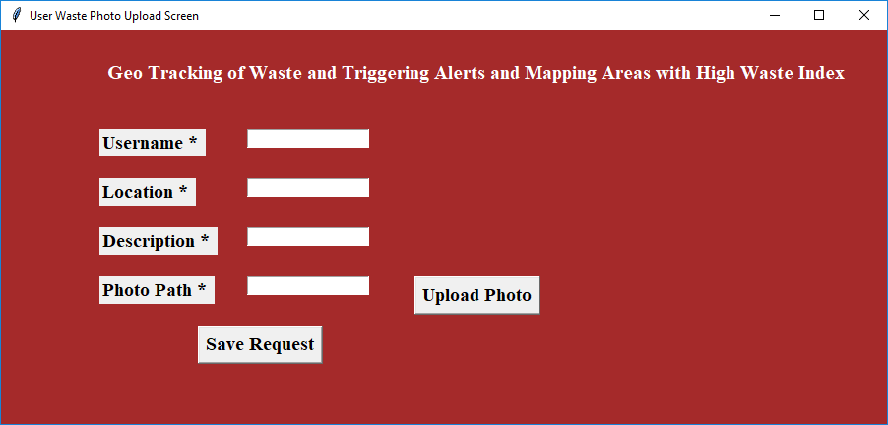

Using above screen user will enter location details with waste upload image

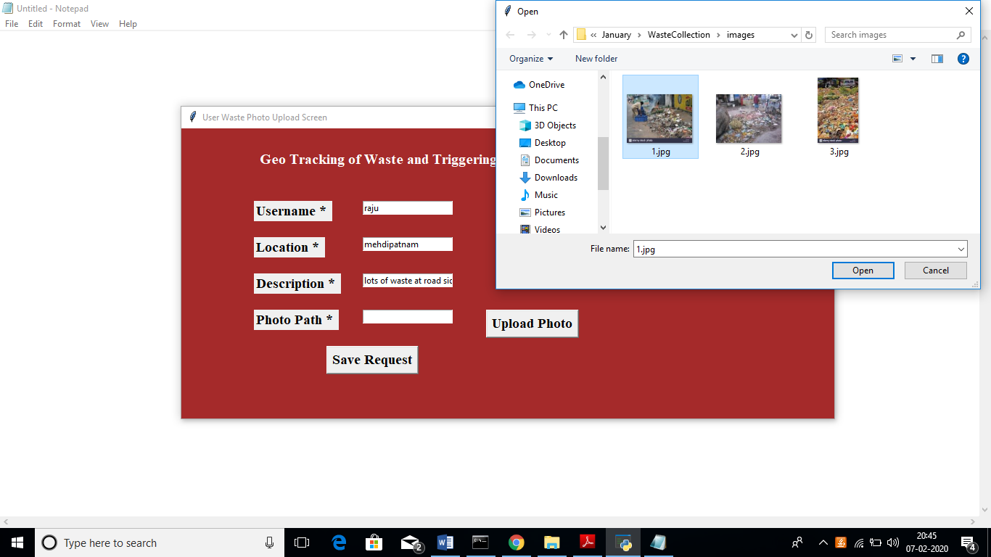

In above screen I entered some details and uploading waste image, after upload image will get below screen

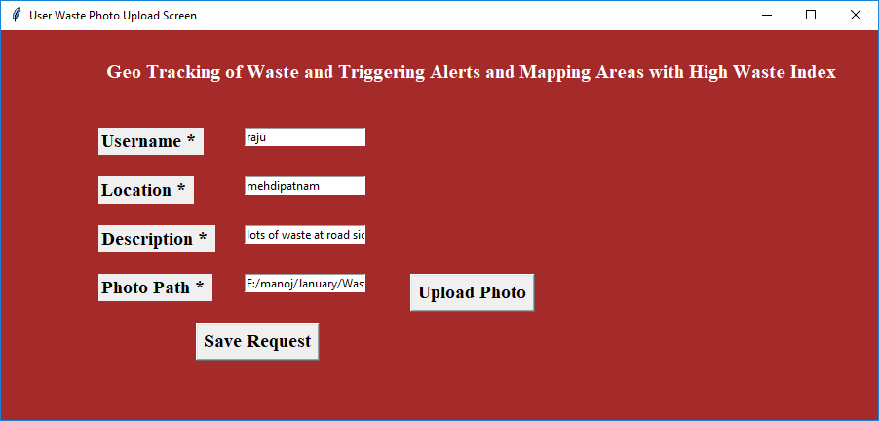

Now click on ‘Save Request’ button to send request to waste collectors

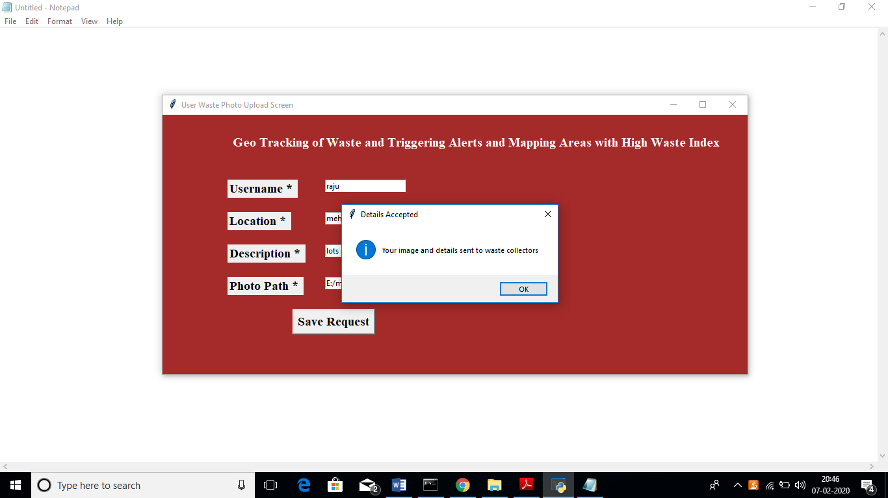

In above screen we can see user request details saved. Now close this application and run waste collector module by double click on ‘Run_Waste_Collector.bat’ file to get below screen

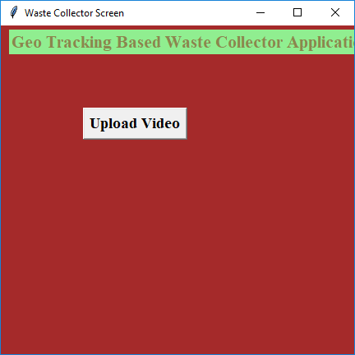

In above screen click on ‘Upload Video’ button and upload video

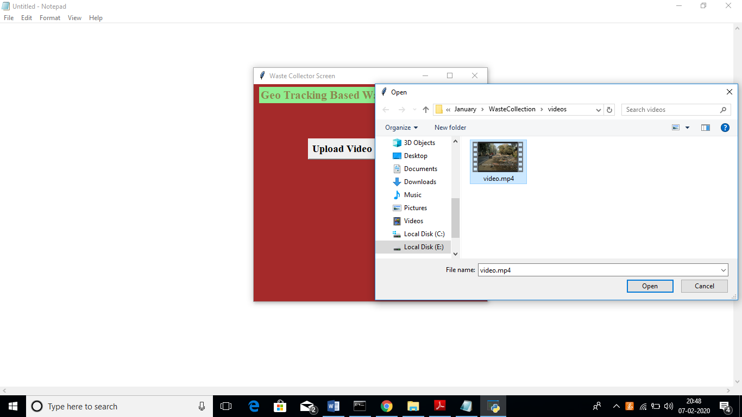

In above screen I am uploading one video and after uploading video will get below screen

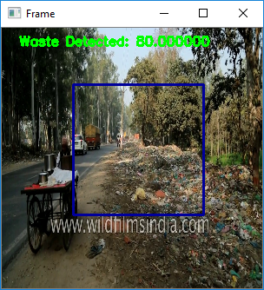

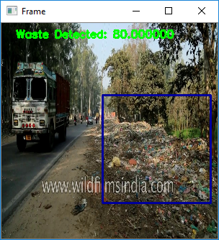

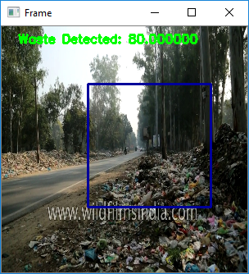

In above screen video starts playing and simultaneously it starts matching pattern with images to inform waste collectors.

**8. CONCLUSION:**

A system that helps in effective waste management at public and private places is designed, developed and tested.

The system identifies waste level in the dustbin, triggers SMS and mail alerts when the dustbin is full, identifies areas which have full dustbins and finds an optimal route for collecting the garbage from the dustbins. The cost of the system is 4000 INR and can be easily fitted in existing private and public dustbins. The experimental results reveal that the system is easy to use, accurate, power-efficient and cost-effective.

**9. REFERENCES:**

[1] Sunil Kumar, Stephen R. Smith, Geoff Fowler, Costas Velis, S. Jyoti Kumar, Shashi Arya, Rena, Rakesh Kumar, and Christopher Cheeseman, "Challenges and opportunities associated with waste management in India," NCIB, [Online]. Available: https://www.ncbi.nlm.nih.gov/pmc/articles/PMC5383819/. [Accessed 20 1 2020].

[2] Balamurugan S, Abhishek A, Snehal Ratnakaran, S. Balaji, R. Marimuthu, "Design of Smart Waste Management System," IEEE, 2017.

[3] Michael Christopher Xenya, Emmanuel D’souza, Koffie-Ocloo D. Woelorm Robert Nii Adjei-Laryea, Ekow Baah-Nyarkoh, "A Proposed IoT Based Smart Waste Bin Management System with An Optimized Route: A Case Study of Ghana," IEEE, 2020.

[4] Maher Arebey, M A Hannan1, Hassan Basri, Huda Abdullah, "A SmartWaste Management Solution Geared towards Citizens," MDPI, pp. 1-15, 2020.

[5] Kellow Pardini, Joel Rodrigues, Ousmane Diallo, Ashok Kumar Das,Victor Hugo C. de Albuquerque, Sergei A. Kozlov, "Solid Waste Monitoring and Management using RFID, GIS and GSM," IEEE, pp. 27-40, 2009.

[6] "Motion Sensor Waste Bin Dry & Wet Smart Dustbin," Reetrix, [Online]. Available: https://www.amazon.in/Reetrix%C2%AE-MotionSensor-Waste-Dustbin/dp/B07R84VB5D. [Accessed 18 2 2020].

[7] "IoT based Smart Waste Management System using Arduino," Pantech Solutions, 8 12 2018. [Online]. Available: https://www.pantechsolutions.net/iot-based-smart-waste-managementsystem-for-smart-city. [Accessed 16 2 2020].

[8] "Arduino UNO data sheet," Farnell, [Online]. Available: https://www.farnell.com/datasheets/1682209.pdf. [Accessed 20 1 2020].

[9] "ESP 8266 data sheet," Components 101, [Online]. Available: https://components101.com/development-boards/nodemcu-esp8266- pinout-features-and-datasheet. [Accessed 20 1 2020].

[10] "Ultrasonic Sensor Datasheet," Electro Schematics, [Online]. Available: https://www.electroschematics.com/wpcontent/uploads/2013/07/HCSR04-datasheet-version-1.pdf. [Accessed 20 1 2020].

[11] "Servo Motor data sheet," Components 101, [Online]. Available: https://components101.com/servo-motor-basics-pinout-datasheet. [Accessed 20 1 2020].

[12] "MPU 3250 Datasheet," Invensense, [Online]. Available: https://invensense.tdk.com/wp-content/uploads/2015/02/PS-MPU9250A-01-v1.1.pdf. [Accessed 20 1 2020].

[13] "Bluetooth Module Datasheet," Components 101, [Online]. Available: https://components101.com/wireless/hc-05-bluetooth-module. [Accessed 20 1 2020].

[14] "XBee Module Datasheet," Components 101, [Online]. Available: https://components101.com/wireless/xbee-s2c-module-pinoutdatasheet. [Accessed 20 1 2020].

[15] "Blynk," Blynk, [Online]. Available: https://blynk.io/. [Accessed 5 2 2020].

[16] "MIT App Inventor: Objectives, Design, and Development," Springer, [Online]. Available: https://link.springer.com/chapter/10.1007/978- 981-13-6528-7_3. [Accessed 5 2 2020].

[17] "How to configure as Coordinator , Router / End Device," alselectro, [Online]. Available: https://alselectro.wordpress.com/tag/s2c-zigbee/. [Accessed 5 2 2020].

[18] "Google OR Tools-A Guide," Google OR Tools, [Online]. Available: https://medium.com/google-or-tools/google-or-tools-a-guide39f439a5cd0f. [Accessed 15 3 2020]. [19] "Traveling Salesman Problem," Google OR Tools, [Online]. Available: https://developers.google.com/optimization/routing/tsp#dist_matrix_da ta. [Accessed 15 3 2020].

[20] "Developer Guide," Google Maps, [Online]. Available: https://developers.google.com/maps/documentation/urls/guide#directio ns-examples-using-waypoints. [Accessed 15 3 2020].